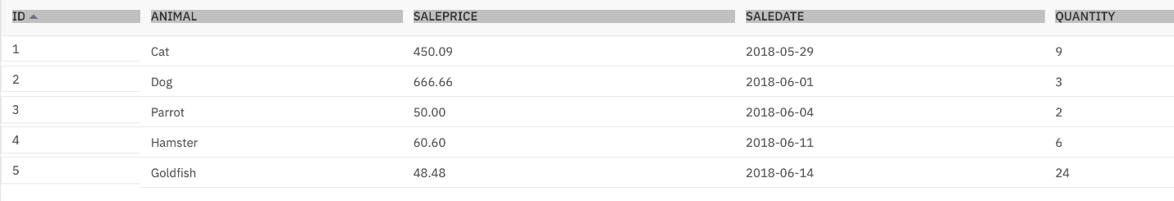

* You will create a stored procedure routine named **RETRIEVE_ALL**.
* This **RETRIEVE_ALL** routine will contain an SQL query to retrieve all the records from the PETSALE table, so you don't need to write the same query over and over again. You just call the stored procedure routine to execute the query everytime.
* To create the stored procedure routine, copy the code below and paste it to the textbox of the **Run SQL** page. Click **Run all**.

--#SET TERMINATOR @

**CREATE** **PROCEDURE** RETRIEVE_ALL -- Name of this stored procedure routine

**LANGUAGE** **SQL** -- Language used in this routine

**READS** **SQL** **DATA** -- This routine will only read data from the table

DYNAMIC **RESULT** **SETS** 1 -- Maximum possible number of result-sets to be returned to the caller query

**BEGIN**

**DECLARE** C1 **CURSOR** -- CURSOR C1 will handle the result-set by retrieving records row by row from the table

**WITH** **RETURN** **FOR** -- This routine will return retrieved records as a result-set to the caller query

**SELECT** * **FROM** PETSALE; -- Query to retrieve all the records from the table

OPEN C1; -- Keeping the CURSOR C1 open so that result-set can be returned to the caller query

**END**

@ -- Routine termination character

To call the RETRIEVE_ALL routine, copy the code below in a **new blank script** and paste it to the textbox of the **Run SQL** page. Click **Run all**. You will have all the records retrieved from the PETSALE table.

**CALL** RETRIEVE_ALL; -- **Caller** query

If you wish to drop the stored procedure routine RETRIEVE_ALL, copy the code below and paste it to the textbox of the **Run SQL** page. Click **Run all**.

DROP **PROCEDURE** **RETRIEVE_ALL**;

CALL RETRIEVE_ALL;

* You will create a stored procedure routine named **UPDATE_SALEPRICE** with parameters **Animal_ID** and **Animal_Health**.
* This **UPDATE_SALEPRICE** routine will contain SQL queries to update the sale price of the animals in the PETSALE table depending on their health conditions, **BAD** or **WORSE**.
* This procedure routine will take animal ID and health conditon as parameters which will be used to update the sale price of animal in the PETSALE table by an amount depending on their health condition. Suppose -
  + For animal with ID XX having BAD health condition, the sale price will be reduced further by 25%.
  + For animal with ID YY having WORSE health condition, the sale price will be reduced further by 50%.
  + For animal with ID ZZ having other health condition, the sale price won't change.
* To create the stored procedure routine, copy the code below and paste it to the textbox of the **Run SQL** page. Click **Run all**.

--#SET TERMINATOR @

**CREATE** **PROCEDURE** UPDATE_SALEPRICE (

**IN** Animal_ID INTEGER, **IN** Animal_Health VARCHAR(5) ) -- ( { IN/OUT type } { parameter-name } { data-type }, ... )

**LANGUAGE** **SQL** -- Language used in this routine

MODIFIES **SQL** **DATA** -- This routine will only write/modify data in the table

**BEGIN**

**IF** Animal_Health = 'BAD' **THEN** -- Start of conditional statement

**UPDATE** PETSALE

**SET** SALEPRICE = SALEPRICE - (SALEPRICE * 0.25)

**WHERE** **ID** = Animal_ID;

ELSEIF Animal_Health = 'WORSE' THEN

**UPDATE** PETSALE

**SET** SALEPRICE = SALEPRICE - (SALEPRICE * 0.5)

**WHERE** **ID** = Animal_ID;

ELSE

**UPDATE** PETSALE

**SET** SALEPRICE = SALEPRICE

**WHERE** **ID** = Animal_ID;

**END** **IF**; -- End of conditional statement

**END**

@ -- Routine termination character

Let's call the UPDATE_SALEPRICE routine. We want to update the sale price of animal with ID **1** having **BAD** health condition in the PETSALE table. Copy the code below in a **new blank script** and paste it to the textbox of the **Run SQL** page. Click **Run all**. You will have all the records retrieved from the PETSALE table.

**CALL** RETRIEVE_ALL;

**CALL** UPDATE_SALEPRICE(1, 'BAD'); -- Caller query

**CALL** RETRIEVE_ALL;

Let's call the UPDATE_SALEPRICE routine once again. We want to update the sale price of animal with ID **3** having **WORSE** health condition in the PETSALE table. Copy the code below and paste it to the textbox of the **Run SQL** page. Click **Run all**. You will have all the records retrieved from the PETSALE table.

**CALL** RETRIEVE_ALL;

**CALL** UPDATE_SALEPRICE(3, 'WORSE'); -- Caller query

**CALL** RETRIEVE_ALL;